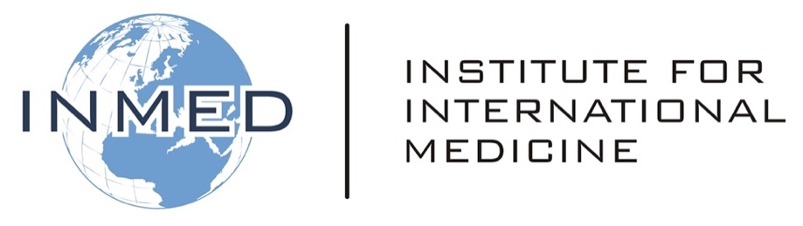
Emergency Pandemic Control
Mid-Term Exam

Your full name:
Your email address:

In response to each of the questions, compose a two-four sentence answer below the question. Some of these questions call for your personal opinion. Please express this along with your rationale. When complete, upload this document according to your course instructions.

1. What elements of the modern world place humans at increased risk for pandemic diseases?

2. Which parties should be responsible for early detection and reporting of pandemic threats?

3. What role do you believe the United Nations and/or World Health Organization should in pandemic detection and response?

4. Which characteristics of human psychology or sociology impede response to pandemic threats?

5. Describe the concept of contact tracing and containment.

6. In the setting of pandemic control, describe the tension between individual rights and public health/governmental rights.

7. What vulnerabilities within healthcare systems have been exposed through recent pandemics?

8. Describe at least one recommended action to close such healthcare system vulnerabilities.

9. What vulnerabilities within society at large have been exposed through recent pandemics? If you wish, you may focus your analysis on a particular nation or community.

10. Describe at least one recommended action to close such societal vulnerabilities. If you wish, you may focus your recommendation on a particular nation or community.

